Görkem Enes Bektaş
bektasgorkemenes@gmail.coım
Politechnika Czestochowa
Berke Can Kaya
bluten07@gmail.com
Politechnika Czestochowa

Signal analysis and Data processing

Laboratory Class - Experiment 1

Statistical moments & Stationarity tests

Introduction

In this laboratory report, we focus on the analysis and processing of signals using statistical moments and stationarity tests. The aim of the experiment is to examine the properties of periodic and random signals by analyzing measures such as mean value, standard deviation, skewness coefficient, and flatness coefficient. Additionally, we explore how signal types impact these statistical measures. By understanding these relationships, we gain deeper insights into the behavior of signals in various contexts, which is crucial for practical applications in data analysis and signal processing.

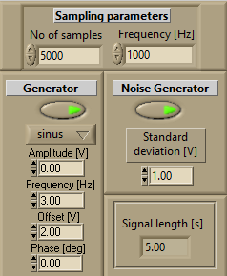

Our settings that we are currently using, our standard deviation is equal to 1V and our Offset is equal to 2V as we can see.

Only for task a, our amplitude will be 1V to get the result of periodic signal.

Compulsory tasks:
a) stationarity tests of selected statistical measures for periodic signal,

We are not using the noise generator so its off. Also a periodic signal doesn’t require any stationary test because its harmonic.

b)- stationarity tests of:
mean value,
standard deviation,
skewness coefficient S,
flatness coefficient F,
for random signal (the number of samples Nopt has to be determined for assumed confidence intervals),

For the mean value, its dependent on our Offset(V) value which is 2V in our experiment. So Mean Value can be seen like;

As you can see, our mean value is mostly near to 2, not directly 2 but always close to that value due to our Offset value. The max error that we can accept is %2, so we will calculate our ranges as (2-2*%2 and 2+2*%2) so our confidence intervals are between 1.96 and 2.04 as we can see on the Y-axis.

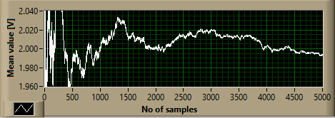
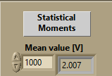

For the standard deviation, the max error we can accept is %3, to calculate we should do;
1-1*%3 and 1+1*%3
so our confidence intervals will be between 0.97 and 1.03

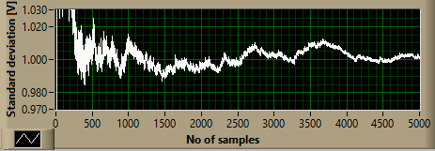
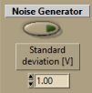

For the skewness, the max error we can accept is %5, to calculate we can check previous steps for the formula. So our confidence intervals are between -0.05 and +0.05.

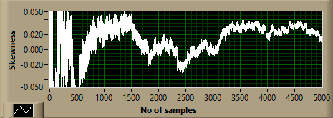



For the flatness, the max error we can accept is %3, to calculate we can check previous steps as mentioned. So our confidence intervals are between 2.91 and 3.09

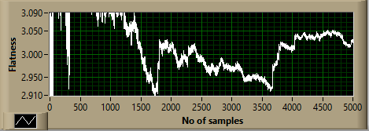



c)
For this task, we will change signal types but we will try to see the difference about when we change our signal types, what changes in our statistical moments.

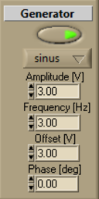
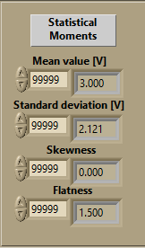

So in here we can see that we have sine wave as our signal type and our standard deviation is equal to √2/2*A as we know with formula, as we can see our Amplitude is equal to 3V so when we do this calculation;
it will be √2/2*3=2.121, and only in sine wave we can get Flatness at 1.5, so we can prove that its a sine wave only by looking at flatness.

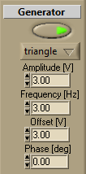
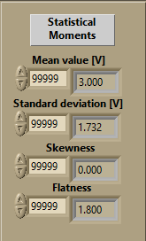

In triangle wave, for example our standard deviation will be different compared to sine wave, in this wave type, we should calculate it as √3/3*A, as we can see our Amplitude is equal to 3V and when we do the calculation;
√3/3*3=1.732, and only in triangle wave we can get Flatness value at 1.8, so we can understand that this wave type is triangle only by looking flatness.

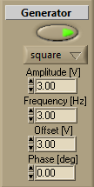
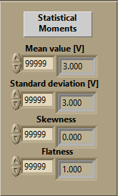

In square wave, we have difference on standard deviation and flatness compared to sine wave and triangular wave. In square wave, our Amplitude value which is 3V, is equal to standard deviation value, and our flatness will be equal to 1. So we can prove this is a square wave only by looking at the standard deviation because it is equal to our amplitude, or by looking at flatness value which equals to 1.

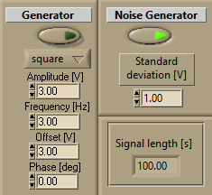
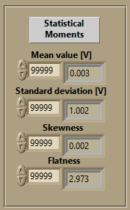

As we can see, we only have Noise Generator active which means we only have pure noise. In this situation, our flatness is equal to 3.

Conclusion

The experiments conducted in this report provided a comprehensive understanding of statistical moments and their behavior under different signal types. We observed how periodic signals maintain harmonic properties, eliminating the need for stationarity tests, while random signals required detailed confidence interval analysis for statistical measures. Moreover, the comparison of sine, triangle, and square waves highlighted the distinct characteristics and calculable properties of each signal type. These findings underscore the importance of statistical methods in signal analysis, enabling precise interpretation and application in technical and engineering fields.

